Two Dynamic Process Models of Covid-19 with Divergent

Vaccination Outcomes

Ernie Chang, MD PhD, Ken Moselle, PhD

January 24, 2021

**INTRODUCTION**

The CovidSIMVL agent-based simulation system is a flexible generator of model Covid-19 epidemics, grounded in viral temporal dynamics from Xi, He {Nature Medicine Aug 2020] using a physical contagion approach with parameters of size and activity.

The parameters of Hazard Radius {“HzR”), Mingling Factor (“mF”), and Symptomatic Days (“Red Days”), within the stochastic approach to agent movement and viral growth, allows CovidSIMVL to generate simulated epidemics of varying dynamics for a single “Fixed Universe” or for interacting multiple Universes in which sub-populations can move from one Universe to another according to deterministic schedules.

In this paper, we introduce two dynamic process approaches to Covid-19 epidemics, and then a population structured by age groups, for which vaccination schedules are simulated. The different outcomes from the two dynamics in terms of vaccination protection will be described.

**WAVE vs PARTICLE Dynamic Processes**

By setting parameters to favour locality of movement for the agents, their HzR (the larger, the more likely two agents will make contact following a cycle of moves), and the duration that Symptomatic Cases remain in circulation, we can model Covid-19 simulated epidemics at different ends of a spectrum.

**METHODOLOGY**

***WAVE Dynamics***

The parameters for the WAVE trial were set to the following:

Population 1,000

HzR 2.1

mF 0.95

“Red days” [8.2] symptoms start at day 5.2 from infection – this is net 3 days

The model dynamics, because of the low mF, constrain the agents to remain close to their locality (despite the stochastic Pareto-like distribution of probable moves), and produce configurations like these:

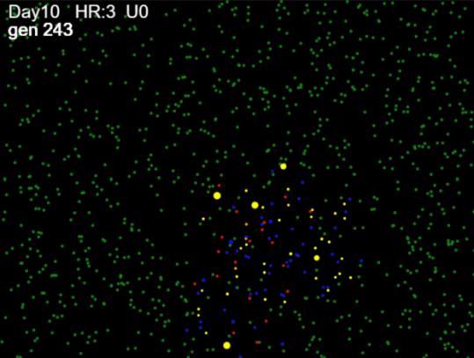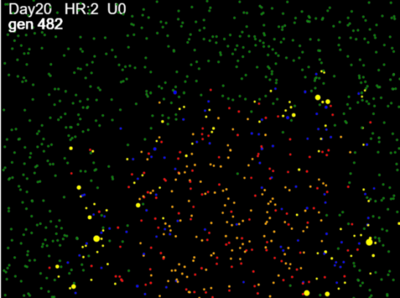

The population of 1,000 is distributed randomly at initialization, and we start with a single infected agent, placed randomly. If the position happens to be in a corner, the contagion spreads like a wave-front; and if the initial position is more central, then the wave front tends to be radial.

We have set parameters, through trial and error, to fully infect (with stochastic margins of error) the entire population. The notion here is not that the study population is the entire population; rather, we would in the scenarios, focus on the 1,000 cases that would be infected. The simulations are not framed to include those who would not be infected. Mitigation, vaccinations are intended to produce positive effects on those who would otherwise not be saved.

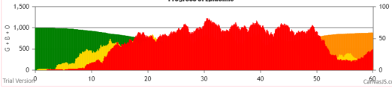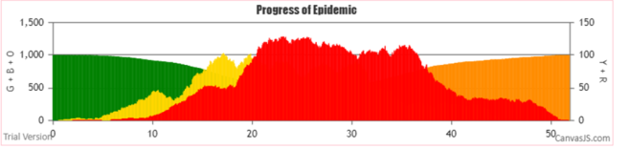The dynamics of this progressive “Wave” like movement of the contagion also produces interesting growth charts, seen below as typical cases per day epidemiology graphs.

The red represents the daily counts of Symptomatic Cases; Greens are susceptibles, and Yellows are Incubating; Orange are agents that have gone beyond the symptomatic days and are now inert.

***PARTICLE Dynamics***

By setting the mF high, and keeping the HzR low, the simulation processes cause agents to move in large jumps within the virtual arena. Thus, contacts and infections more closely resemble the mass action assumptions of equation based epidemiology models. The virtual arena appears as below.

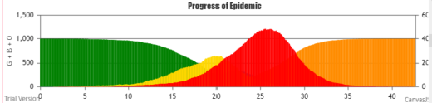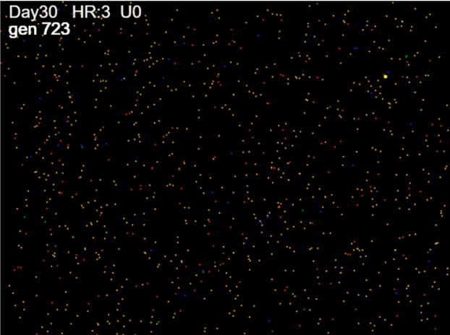

Despite the tiny dots of color, it is obvious that the agents in various states are distributed randomly. Furthermore, the distribution of the symptomatic cases fits perfectly (almost) into a symmetrical Bell shaped curve.

The parameters for this trial were: HzR 1.3, mF 7.5, and Red Days 9.9. This trial ended with zero survivors, in 1024 generations (each generation is considered an hour, and changes are made every generation).

The WAVE Simulation ended at Gen 1246 (51 days and 22 hrs), with 2 survivors out of 1,000.

**RESULTS**



The metric theta.all refers to “theta” as TIME/#infections. For any period, this gives the average time between infections, which is a measure of the aggressiveness or speed of the epidemic. Here, theta.all refers to the total time to the last infection divided by the number of infections.

The rate for WAVE is 1.05 generations between infections, while for PARTICLE it is 0.79 generations per infection. This is a quantification that can be applied to any time interval.

***Console.log***

Through use of the console.log, the CovidSIMVL program is able to produce a trace of every infection, its time (in generations), and other state information, as seen below.



From this chronology, we created frames of 60-generations starting at generation 300 (approximately Day 12.5), and within each frame, counted the number of infections that occurred. There is some delay and merging between the infection history and the chart, because the symptomatic cases stay around for 4.7 days in the PARTICLE model, and for 3 days in the WAVE model. However, we compare infections in what follows, rather than case per day as in the chart.



This table shows that the PARTICLE processes were more active in all 60-generation frames (more infections, more spread), but interestingly, the WAVE dynamics gave roughly the same number of infections in each frame, thus accounting for the plateau in the chart above.

The relationship between the truncated cone of the PARTICLE process and the WAVE can be visualized in the graph of the table above. It would appear that the cases from the top of the cone have been distributed over time in the WAVE scenario.

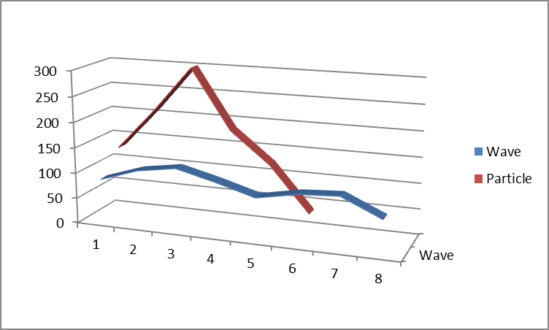

***Internal Dynamics of WAVE vs PARTICLE.***

In the table below, we show thetaNNN where NNN is the infection number. There are 1,000 agents in the population, and the console.log lists them in order of infection, along with the generation tag. Thus, for theta 100, we take the first 100 infections, identify the time of the first and last, thus finding the total elapsed time for this 100. Theta100 is then time/# which is elapsed/100.

Similarly, theta200 is in this table, used with local reference. In other words, instead of the total time from start to 200 infections, we use the time for the second 100 infections, and so on.



Each value of theta is the time/per infection, and the larger it is, the slower the epidemic. Since we start with only one infected person, the epidemic has to create more simultaneous infectors, so in both cases theta100 is a relatively large number.

In the case of WAVE, the theta values are pretty consistent between theta300 and theta800 at around 0.5 to 0.6. This is in contrast to PARTICLE, which in keeping with the Bell curve, decreases in theta to a low of 0.17 at theta600 and increases on each side, with theta values smaller (faster) than the comparable WAVE theta values in the same intervals.

The interesting observation here is that the exponential growth of the epidemic, which is reflected by the Bell curve, and is in keeping with the random infection assumption of equation-based modelling, may not hold if the process dynamics tend toward WAVE. There is a possibility inherent in these two models that the exponential growth can be replaced by polynomial growth, which extends the time and reduces the peak of the epidemic. WAVE conditions are simple: restricted movement of all agents.

***Age-Group Frequency of Transmission***

Using the no-vaccination trial for WAVE, we derived from the console.log the number of infections transmitted by agents from all age groups, with the following results.



This shows that of 1005 infections, the 20-59 groups accounted for 70% of all infections, as well they should since they also account for 69% of the study population. On this basis, we run some trials in the next section to study the extent to which vaccinating the transmitters alone protected the elderly.

**II. AGE-STRUCTURED POPULATION AND VACCINATION MODELING**

The capabilities of CovidSIMVL permits the system to specify the age-groups of the population, and to implement vaccination schedules for a percentage of an age group in a Universe. In this paper, we explore the effects of WAVE vs PARTICLE in a single Fixed Universe.

The population of 1,000 has been carefully tailored to reflect morbidity due to Covid in British Columbia, using 2020 Covid-19 data from Jan 15 to December 12, 2020.

***Age-Tables***



This is the data from British Columbia CDC for the period Jan 15 – Dec 12, 2020. We calculated the new column “Cases% AgeGp” by taking the “Cases n” for each ageGp as a percentage of the “BC Popn” by AgeGp.

We use this column to construct a new table of 1,000 cases in the following way. First we fix the total “Cases n” at 1,000. Then we use the “Cases % Total” to fill the new “Cases N” rows for each age group. Thus, for age group <10, from “Cases % Total” of 3.99% X 1,000 (total in “Cases n”) we get 40, and so on.

Next, we use the derived “Cases% AgeGp” to calculate the BC population. So, if 40 cases make up, from “Case% AgeGp”, 0.37% of the BC population, the BC population for the age group <10 would be 40/0.37% or 10,775, and so on for the other age groups.

We end up with the following table distributing the 1,000 patients into age-groups using “Cases n”.



This table is useful as the age structure is the same as the morbidity structure reported, but for 1,000 cases. This is the approach in which we want to set the parameters so that all 1,000 will be infected, and their subsequent hospitalization, ICU, and deaths follow from the known percentages.

With this population, studying the effect of vaccinations will allow us to understand not just the cases that may be spared, but also the consequent downstream hospitalizations, ICU and deaths.

***Vaccination Mode in CovidSIMVL***

In a previous paper, we discussed the different modes (one jab or two jabs) for the Pfizer, Moderna vaccines if they are followed to the EUA (Emergency Use Authorization) of the manufacturers, and the potentially favourable outcome of a hypothetical Hybrid vaccine.

In this version of CovidSIMVL, we have extended the user parameter selection to permit entering an age group and a percentage, applying to persons who are in the Universe at hand. The console.log records the vaccination and assigns it Mode 2 (two jabs).

The vaccine is assumed to be inactive for 14 days with no protection, then with 75% protection till day 28, after which the person has 95% protection. The vaccine’s efficacy is implemented at the time a contact has been detected between a viral carrier and a susceptible. If the random number drawn is greater than the threshold of protection, the viral transfer continues, otherwise the contact is nullified.

The vaccinated person is able to transmit at the same level as the protection given to a susceptible. In other words, if the random number drawn is greater than the threshold (say 95%) the transmitter may infect.

The console.log produces a trace of vaccination protected encounters, both on the susceptible and the receiving end.

**METHODOLOGY**

A number of trials were run, with varying parameters. They are described below, and the results are then reported and discussed briefly for each set of trials.

First, note that the vaccine temporal model as described above has the first 14 days with no protection. We call this the **STANDARD** approach. A second set of trials are repeated, using the **FAST FORWARD** “FF” approach, in which the date of first injection is recorded as 14 days prior to the ***current date***, so that effectively, the second injection takes place at the time the vaccination is initiated during the trial. NOTE: in the trials that follow, the vaccinations are given at time T=0.

Two sets of mobility parameters are used for WAVE and PARTICLE, as described above. To reiterate,

WAVE red days=8.2 HzR=2.1 mF=0.95

PARTICLE red days=9.9 HzR=1.3 mF=7.5

Again, recall that “red days” are the value of days from initial infection, and onset of symptoms is at 5.2 days after initial infection, so the duration of “red days=8.2” is 3 days after onset.

The vaccination schedules are as follows:

Schedule 0 no vaccination for any age group

Schedule 1 100% for groups 9,8 and 7 Age Groups 90+, 80-89, 70-79

Schedule 2 100% for groups 9,8 and 7 50% for groups 2,3,4 20-29, 30-39, 40-49

Schedule 3 100% for groups 2,3,4 and 5

Schedule 3 is to test the influence of suppressing transmitters alone on the risks to the elderly.

The trials terminate when no further infections are possible. The final status of all age groups is produced below for WAVE and PARTICLE.

In summary, then, we start with the **STANDARD** approach (14 days of no protection, then 75% to day 28, then 95% protection).

Within this, we compare the results of Schedule 1, 2 and 3 for WAVE and PARTICLE processes.

**RESULTS**

***STANDARD APPROACH***

From the trials, the summary results using the console.log are shown in the table below.



The key observations are:

1. Schedules 2 with Gp9,8,7 at 100% with Gp 2,3,4 at 50% vaccinated is the most protective of the three vaccination approaches.
2. Vaccinating just Gp 2,3,4,5 at 100% does not protect the elderly In Gp 9,8,7 (shown in orange).
3. WAVE is consistently slower (terminations) and more protective than PARTICLE. Looking at theta values, we have:  
     
     
     
     
     
     
     
     
     
     
     
     
     
     
     
     
     
   Recall that theta is the value in generations of the time between subsequent transmissions, within a time frame. Here, theta.all is the total time frame from first to last infection, and gives the average of the separation between all transmissions within a trial. In the table above for the Standard approach, theta for WAVE is consistently higher than for PARTICLE.  
     
   The number of survivors of WAVE vs PARTICLE in the ***Standard Approach*** is also consistently higher.
4. The overall immunity conferred at termination is about 50% of the vaccination levels.

***FAST FORWARD APPROACH***

Recall that we adopt here a scenario in which we consider a population age-structured as described (to reflect infection distribution in the BC population), but the vaccinated group have their vaccinations back-dated to 14 days before the start of the trial. In other words, their immunity begins right away at 75%.

In this scenario generation, we are in a thought experiment in which we consider what happens to the 1,000 age-structured populations that start with the vaccination patterns prescribed, with them still susceptible and now getting their second injection at time the trial starts.

This micro-Simulation virtual clinical trial allows us to see the difference that the 14 days of zero immunity makes on the vaccinated (and the whole) population.



The key observations are:

1. The times to termination are higher than in the Standard Approach.
2. The overall protection is higher than in the Standard Approach.
   1. For WAVE, the survivors are 54-268-579 compared to 34-182-481 for Standard
   2. For PARTICLE, the survivors are 68-294-647 compare to 14-91-390 for Standard
3. The WAVE survivorship is now marginally lower than PARTICLE compared to the Standard approach. For example, for Schedule 1 and Schedule 2, the WAVE vs PARTICLE survivors are:
   1. Schedule 1 – WAVE to PARTICLE: 54 to 68, where it was 34 to 14 in the Standard appro
   2. Schedule 2 – WAVE to PARTICLE: 268 to 294 where it was 182 to 93.
4. The Schedule 3 approach of vaccinating transmitters in Gps 2,3,4,5 does not protect the elderly.

***STANDARD vs FAST FORWARD APPROACHES***

The thought experiment of Fast Forward permits us to see clearly the contribution of the 14-day unprotected period to the survivorship of the age-groups in the various vaccination schedules. This can be seen in the table below.



The “WAVE 14d” and “PARTCLE 14d” are the differences in the counts of survivors for the Age Groups

90+, 80-89, 70-79 cumulated. In the WAVE dynamic, the infections in the 14 days of no protection are 18-19 for both the Schedule1 and Schedule2, each of which protects these Age Groups at 100%.

In the PARTICLE dynamic, the difference in both cases is much higher, at 53 and 63. The Schedule 3 offered no vaccination to these Age Groups, and it is clear that vaccinating the high transmitters did not contribute to indirect protection significantly. The value of 15 for WAVE Standard approach being higher than the WAVE Fast Forward is counter-intuitive, and we will discuss this below.

***DISCUSSION***

Dynamics of WAVE vs PARTICLE

Given our Monte Carlo physical movement approach, WAVE has parameters of 0.95 for Mingle Factor compare to 7.5 for PARTICLE, which means that the agents in WAVE stay in place, compare to volatile large movements for PARTICLE.

This leads, as we have seen, to the spread of infection as a virtual wave front, in which infected agents at delta distances from the transmitter become the new margins of the epidemic. In comparison, PARTICLE agents are all moving at significant distances and this separation takes them to new neighbors.

In the Standard approach, transmitting WAVE agents have to find new uninfected agents in their neighborhood to keep the epidemic going, and this dynamic is subject to local saturation. In contrast, with the PARTICLE agents, each new position finds high susceptible neighbors, until arena-wide saturation effects start occurring.

This produces the observations that theta.all for Standard WAVE trials are consistently higher than for PARTICLE processes.

Dynamics Affected By Vaccinations

When there are vaccinated agents, and many of them, the transmitters are rejected often, and as the console.log shows (in the Appendix), toward the end of a trial there are many more failures than successes in transmission. This is why the trials take longer in Fast Forward than in Standard – in Standard, susceptible agents are infected quickly in the first 14 days, but in Fast Forward, resistance is immediate.

In both the WAVE and PARTICLE processes, the presence of many vaccinated also slows the creation of more simultaneous transmitters, and whether in Standard or in Fast Forward approaches, thus prolonging the overall time, and increasing the number of survivors at termination.

The effect of removing the 14 day unprotected infection in the Fast Forward approach accentuates this reduction of simultaneous transmitters, and we would therefore expect that the survivor count goes up, while the total time to termination also increases. This is borne out in the tables above for STANDARD and FAST FORWARD, and in the Charts below.

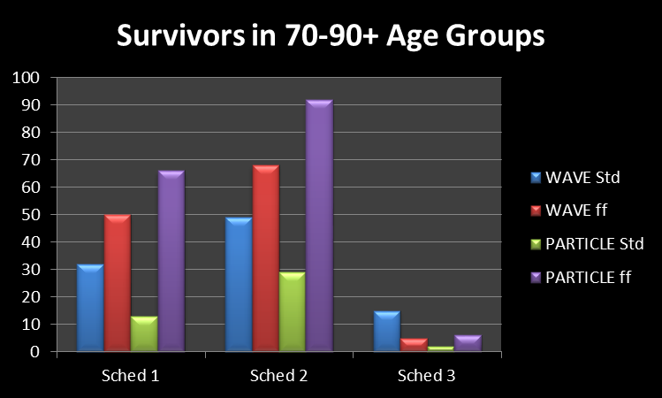

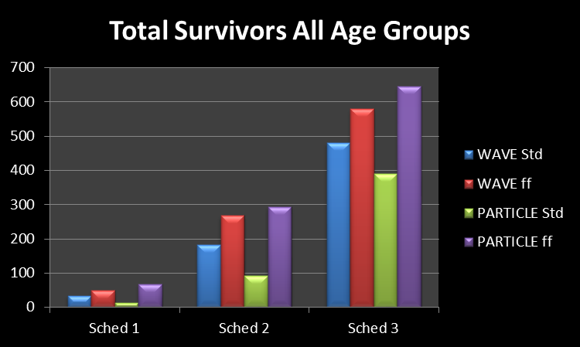

Schedule 1 vaccinates the Age Groups 90+, 80-89, and 79-79. We see in the 70-90+ chart that indeed WAVE in Fast Forward has more survivors, and PARTICLE in Fast Forward also has more survivors than PARTICLE in Standard approach.

A remarkable and consistent observation is that WAVE in Standard approach has higher survivorship than PARTICLE in Standard, but WAVE in Fast Forward has consistently fewer survivors than PARTICLE in Fast Forward (compare the blue and green, versus the red and purple).

The difference between Standard and Fast Forward is 14 days of unprotected transmission for those who have been vaccinated (Schedule 1 has 98 vaccinated, Schedule 2 has 378, and Schedule 3 has 690). This head start permits the PARTICLE agents to have created freely a significant number of transmitters by day 14, whereas in the way the trials are run, the PARTICLE dynamic starts in Fast Forward with a SINGLE transmitter, encountering resistant agents immediately.

On the other hand, the WAVE dynamic is less affected by the discrepancy between creating simultaneous agents freely in the first 14 days, as the slower neighborhood crawl of the wave front reduces the growth of simultaneous agents. We can see this in the table from above, shown again here.



At day 12.5 and 15, the Standard approach for WAVE has 85 and 110 infections in the 60 generation time frames, while the PARTICLE dynamic has 130 and 211 transmissions. This attests to the loss that the Fast Forward approach imposes on PARTICLE, and the greater survivors that PARTICLE has in this mode.

The other Chart is that for All Ages, and we see the same kind of relationships, including in Schedule 3, in which only Age Groups 20-29, 30-39, 40-49 and 50-59 are vaccinated at 100%. However, the 90+ Chart shows almost no survivors, thus rejecting that the hypothesis that vaccinating transmitters alone is significantly protective for the other age groups.

***Intensity vs Time***

In the first part, we made the observation that the WAVE dynamic process is both slower and of longer duration than PARTICLE. The characteristic case charts for PARTICLE follows a bell curve while WAVE charts have a longer base with a truncated cone. The total number of infections (the population of 1,000) is the same, so what this observation implies is that we can trade intensity for time. A deeper and more exciting notion that follows is that the epidemic can be converted from an exponential growth to a polynomial growth through restriction of active motion of agents.

**SUMMARY**

In this paper, we have defined two dynamics for simulated contagion processes based on viral temporal dynamics for Covid-19, on the extremes of agent movements that are either relatively local or with large displacements, and these were named WAVE and PARTICLE.

We defined a patient population of 1,000 with age distributions similar to that of the case prevalence of Covid-19 in BC for the period January to December 2020, and applied the two dynamic parameters to this population.

From this, we derived characteristics for these two dynamics, regarding the rate of progression of the epidemics in terms of ***theta***, the time in generations between subsequent infections in a given time frame, and noted the trade-off of time for intensity in WAVE.

We then applied vaccination schedules to the populations, focusing on protecting the elderly with 100% vaccination, then adding 50% to age groups 20-49. Finally we tested the hypothesis that vaccinating the most infectious age groups might protect the elderly. We modified the vaccination trials to a mode in which we FAST FORWARD on the time lag for vaccination protection, so that we negated the 14-day wait time after the first injection.

The results of the vaccination trials are discussed in detail above. The summary is that that while vaccinating age groups do bring significant increases in survivors, it is only in Schedule 2 in FAST FORWARD for WAVE and PARTICLE do we see survivorship > 50% for the elderly age groups.

This is no doubt due to the rather aggressive dynamics that we set, the reason being that we tried to find the lowest parameters that would ensure an almost complete infection for the 1,000 population, in order to study the effects of vaccination on protection in an active epidemic. We could have lower infection base rates, but the vaccination protection would have to remove the “natural survivors” from the lower intensity epidemic.

These simulations are scenarios, and their relationship to In Real Life is by no means predictive or assured. Nevertheless, this kind of simulation, which technically is a Monte Carlo Markov Chain (MCMC) microsimulation of a clinical trial, permits the elaboration of possibilities and measurements in ways that cannot be realized IRL.

The benefits from the case generations of this study population of 1,000 can easily be carried over to the percentages that are hospitalized, go to ICU or suffer death from the tables generated. Since there are no cost estimates for these downstream events, we leave their elaboration to others.

**APPENDIX. SHOWING REPEALED INFECTIONS DUE TO VACCINATION EFFECTS**

At the start of a trial in Fast Forward PARTICLE dynamic with Groups 2,3,4,5 vaccinated at 100%





Near the end of the trial.